UC6 – Make a payment

Short Description
Customer wants to make a payment. System shows default value to pay balance in full. Customer may modify payment amount. If customer modifies payment amount less then Total Past Due then system tell customer that he must pay at least this amount. Customer may use credit card or check to make a payment

Resources
https://www14.secure-website.net/~wh35591/DPI/DPI_entry.htm

Preconditions

Main Flow
- Customer review Total Past Due, Current Charges and Total Due (Total Past Due + Current Charges) on Account Summary and decides to make a payment
- System shows payment selection screen with account number, Past Due Charges and Current Charges. Customer may modify amount he wants to pay
  - If Past Due Charges equal zero, don’t show Past Due charges line
  - Amount cannot be less then Total Past Due.
  - Amount cannot be less then minimum payment amount. Need to ask TFRY what it is (lets say $10).
  - Amount cannot be bigger then max amount (Ask TRFY what it is Lets say $200.00)
  - If there are only N (I think 5 need to verify where to get this number from db with TFRY and JK) days left until the Due Date, don’t allow modification of total payment.
- Customer Selects “Pay by Credit Card” or “Pay by Check”
  - If Credit Сard chosen, Execute use case UC6.1 MakePayment By СС
  - If Check is chosen, Execute use case UC6.2 Make Payment By Check

Alternative flows

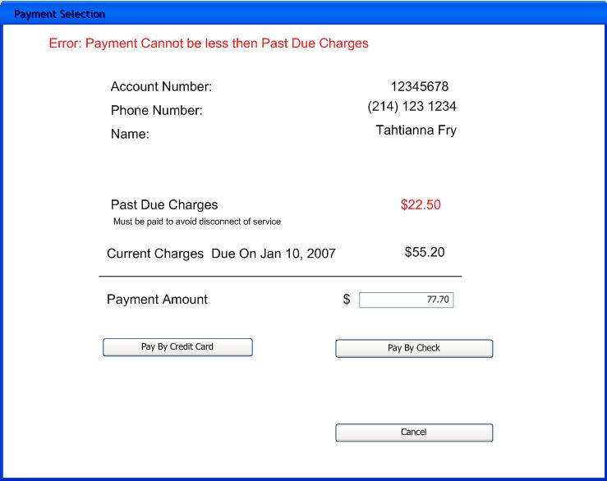

UC61 – Make a payment by Credit Card

Short Description
Customer selected to pay certain amount by credit

Resources
https://www14.secure-website.net/~wh35591/DPI/DPI_CC.htm#

Preconditions
Amount to pay already known

Main Flow
- System shows the following fields:
- Account Number (read only)
- Phone Number (read only)
- Last Name (pre populated, can be modified)
- First Name (pre populated, can be modified)
- Street Address (pre populated, can be modified)
- City, State and Zip
- Email address
- CC Type
- Credit card number
- Expiration date
- Expiration month
- Expiration year
- CVW2 Security Code
- Payment Amount (Read only)
- System execute UC7 – Pre Validate Credit Card (need to create it to use in both recurrent payment setup and here)
- System checks if there is no payment on the same amount on the same CC already entered today
- System Records Demand for CC payment in Pending Status
- System Records Payment Info
- System Records Customer Info
- System sends CC information to e-complish
- System inserts Verifone Transaction and Updates Demand Status to Completed
- System inserts account note saying ...”Need to verify with TFRY”
- System displays receipt to the customer
- System emails receipt to the customer
- Customer may choose to go to account summary or logout

Alternative Flows
2.a Pre Validation of card failed:
1. System shows which field failed and tells customer requirement for this field
3.a Payment on the same amount on the same card was made today
1. System shows message “Payment of $20 dollars on this CC was already received today.” System does not allow duplicate payment.
7.A. e-complish rejected the credit card
1. System shows message received from the e-complish to let customer know why payment was not succss
2. System updates Demand Status to “Rejected”
3. Customer may modify information and try again
7B. Cannot correct to e-Complish
- System shows message that “Sorry cannot take payment at this time)(Need to verify message)
- System updates Demand Status to UnableToComplete
7C. Exception was received from e-complish (network error or any other unexpected error) on reply or reply was not received
- System show message to the customer “Your payment was received, it will have 24 business hours to complete”
- System update Demand into status NeedVerification

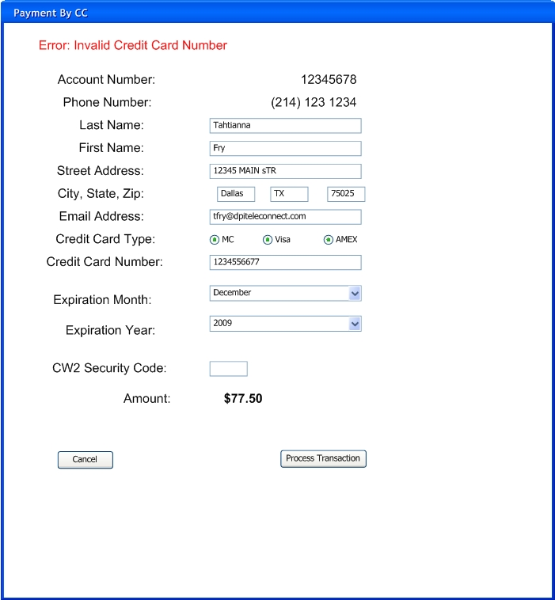

UC62 – Make a payment by Check

Short Description
Customer selected to pay certain amount by check

Resources
https://secured-server.biz/dpi/

Preconditions
Amount to pay already known

Main Flow
- System shows the following fields:
- Account Number (read only)
- Phone Number (read only)
- Last Name (pre populated, can be modified)
- First Name (pre populated, can be modified)
- Street Address (pre populated, can be modified)
- City, State and Zip (pre populated, can be modified)
- Email address (pre populated, can be modified)
- Driver License Number (pre populated, can be modified)
- Driver License State (pre populated, can be modified)
- Bank Routing Number (pre populated, can be modified)
- Bank Account Number (pre populated, can be modified)
- Payment Amount (Read only) (pre populated, can be modified)
- System execute UC8 – Pre Validate Check Info (need to create it to use in both recurrent payment setup and here)
- System checks if there is no payment on the same amount on the same Bank already entered today
- System Records Demand for Check payment in Pending Status
- System Records Payment Info
- System Records Customer Info
- System sends Check information to e-complish
- System inserts Verifone Transaction and Updates Demand Status to Completed
- System inserts account note saying ...”Need to verify with TFRY”
- System displays receipt to the customer
- System emails receipt to the customer
- Customer may choose to go to account summary or logout

Alternative Flows
2.a Pre Validation of check failed:
1. System shows which field failed and tells customer requirement for this field
3.a Payment on the same amount on the same card was made today
1. System shows message “Payment of $20 dollars on this CC was already received
7.A. e-complish rejected the check
1. System shows message received from the e-complish to let customer know why payment was not succss
2. System updates Demand Status to “Rejected”
3. Customer may modify information and try again
7B. Cannot connect to e-Complish
- System shows message that “Sorry cannot take payment at this time)(Need to verify message)
- System updates Demand Status to UnableToComplete
7C. Exception was received from e-complish (network error or any other unexpected error) on reply or reply was not received
- System show message to the customer “Your payment was received, it will have 24 business hours to complete”
- System update Demand into status NeedVerification

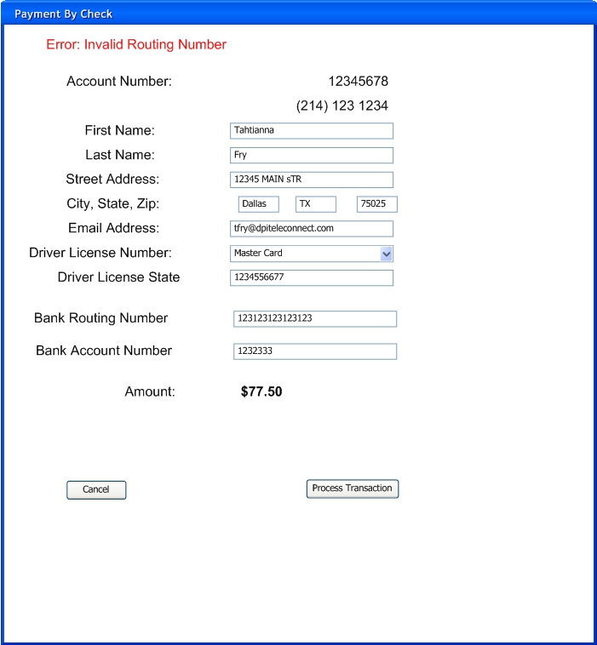

Tables involved
